MAMA MELLI CHILDCARE CENTER
PARENT HANDBOOK
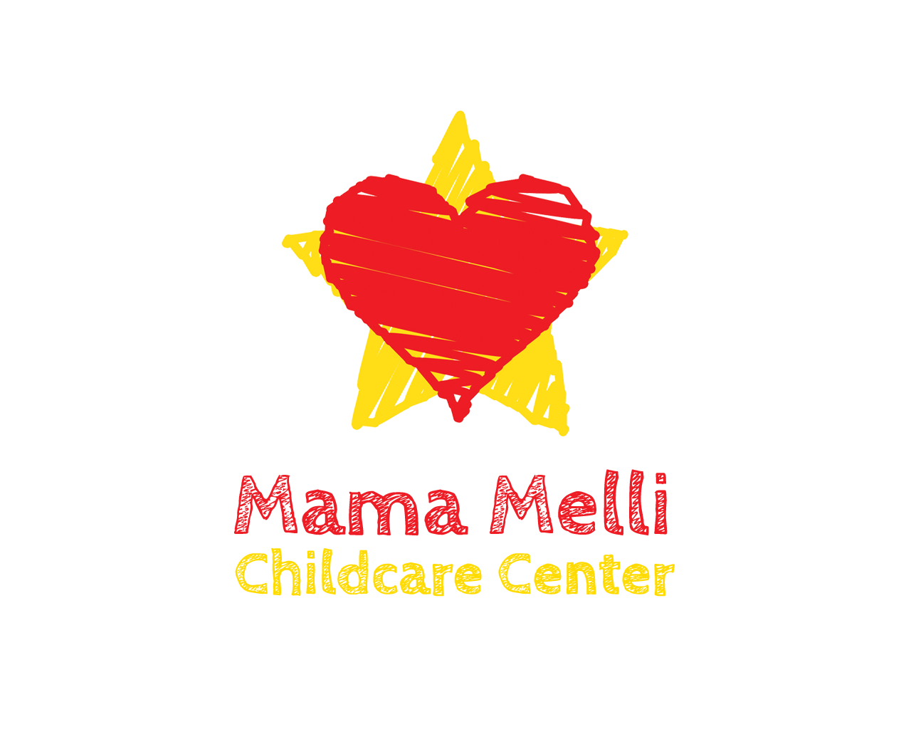

Play. Love. BE.
Mission Statement
At Mama Melli Childcare Center we believe a whole child holistic approach to childcare can change the lives of young children. This is why we offer a loving environment that looks out for the health and wellbeing of your child in the way she eats, the way he thinks, the way she breathes, the way he heals, the way she socializes, and the way he plays. And, most importantly, we have a blast every day!

Mama Melli Childcare Center
Austin, TX
Phone: 512-922-9796
Email: info@mamamellichildcare.com
Website: www.MamaMelliChildcare.com

WELCOME! AND THANK YOU FOR JOINING THE MAMA MELLI FAMILY!
All of this information is current as of September 2017.
PHILOSOPHY: At Mama Melli Childcare Center, we provide a safe and loving environment that enriches a child’s self awareness, self growth and self love while nourishing their bodies with high quality food, their minds with new concepts, their spirits with the practice of mindfulness and their hearts with healthy friendships. We play, we learn, we have fun and we love love love! We believe exposing our children to this type of environment this early on can change their lives and change their world!
And we’re here for the parents as much as we are here for the children. Childcare can be a challenging transition for everyone and we strive to make it flow as smoothly as possible for all parties involved. To help put parent concerns at ease, we encourage open communication, we get them involved with monthly meet ups and we provide continuous access to the owner should any questions or concerns arise. We can’t do this without them!
DAILY SCHEDULE: To see a detailed breakdown of how our day usually flows, please refer to our document Daily Schedule(ish).
AGES: 18 months through age 4 ½, unless otherwise agreed upon.
HOURS: Full time care hours are 7:30 a.m. – 5:30 p.m. Monday – Friday, year round.
TUITION/FEES: We make every effort to keep fees and tuition as low as possible, but should an increase or change occur, we would provide timely notice to parents.
TUITION: At time of enrollment, you will pay the first month’s and 1/2 last month’s tuition. 4-week advance notification is required to pull your child from our care. If you do not give us that 4-week notification, you will NOT get your last month’s tuition payment returned.
2 days/week: $480/month
3 days/week: $720/month
Full Time: $1200/month
You also have the option to pay 3 months in advance to receive a 10% discount.
SUPPLIES FEE: To be paid annually at the beginning of September. If care begins in the middle of the year, then the remainder is due with the first month’s tuition.
Full Time: $180/year
Part Time: $120/year
LATE FEE: $10.00 for every 10 minutes after 5:30 p.m.
PAYMENT: Payment obligation is based on the days YOU AGREE to use childcare, not on actual hour of attendance. Payment is due if you have agreed to use blocks of time whether or not your child actually attends. This includes vacation and sick time. An additional charge of $25 will be added for all late payments (after 5 days of date due) and returned checks.
ENROLLMENT FORMS: Parents are responsible for completing enrollment forms prior to care. They must be updated annually. If there are any changes in the telephone numbers, addresses, etc., it is the parent’s responsibility to inform the Center as soon as possible.
CHANGE IN POLICIES: Should there be a change in our policies or procedures, the change will be posted on our information board and a new Parent Handbook will be provided. You will then be asked to sign a confirmation stating that you were notified of the changes.
VISION AND HEARING: Children who are four years of age as of September 1st must have their vision and hearing tested.
IMMUNIZATION REQUIREMENTS: If your child is not fully immunized, you must provide an Exemption From Immunizations for Reasons of Conscience Affidavit Form. You can request this form at https://corequest.dshs.texas.gov/.
Employees are given the same rights as the children, regarding vaccines.
HOLIDAYS AND BREAKS: Mama Melli Childcare Center will be closed on major holidays. PAYMENT IS DUE FOR THOSE HOLIDAYS IF IT FALLS ON YOUR REGULARLY SCHEDULED DAY. The major holidays are:
New Year’s Day (days closed may vary)
Spring Break (dates will vary)
Memorial Day
4th of July
Labor Day
Thanksgiving (and the day after)
Christmas (days closed may vary during the Christmas/New Year’s holiday season, but you will be responsible for payment on all days closed if it falls on your regularly scheduled day).
VACATION: Fees are waved ONLY during childcare vacation. Mama Melli Childcare Center will provide a vacation schedule in advance.
MEALS: Mama Melli Childcare Center will provide a.m. and p.m. snacks only. All food provided by the Center will be gluten-free and it is preferred that the food prepared for the child by the parents be gluten-free as well, but it is not required. Mama Melli is not responsible for the nutritional value of the lunch provided by the parents or for meeting the child’s daily food needs.
Food allergies: If your child is allergic or sensitive to a particular food, you must fill out the Food Allergy and Anaphylaxis Care Plan FARE Plan. Parents must provide acceptable substitutions if desired. Please notify the Director upon enrollment if this applies to your child.
If your child will not be eating the Center’s food, you may provide a meal from home. Please ensure that the meal is nutritious and do not include food such as candy, gum, sweets or soda.
ARRIVAL AND RELEASE OF CHILDREN: Parents are required to sign the attendance sheet upon arrival and departure. Every child must be signed out. Our responsibility begins when you place your child in the care of a staff member and ends when you take him/her from the care of a staff member. Please do not allow your child to wander off unattended or leave the building ahead of you. Children will only be released to a parent or persons authorized by the parent (listed on the enrollment forms, after verification and copy made of ID). Notice of persons other than the parent picking up the child is preferred. If a circumstance should arise for someone other than those on your list to pick up your child/children, you will need to update your list in advance.
When dropping off your child, please sign your child in on the attendance sheet, hang his/her bag on the assigned hook, remove shoes and place in assigned bucket and bring lunch and water inside.
ILLNESS: If your child is so ill, that they need special care, and they are not able to participate normally in Center activities, they should remain at home. For the wellbeing of our children, Mama Melli Childcare Center will NOT accept a child with a fever of 101+ (child must have regular temperature for 24 hours prior to attending), vomiting or diarrhea, a suspicious rash/blisters or anything else other than a cold, persistent hacking or congested cough with sore throat, difficulty in breathing, convulsions, persistent pain in abdomen, unexpected profuse sweating, head lice, infectious skin or eye conditions. Regular fees will apply when a child is absent due to illness. If your child gets ill while under the care of Mama Melli Childcare Center, it is your responsibility to have your child picked up in a timely manner. In the event that your child becomes ill and we cannot locate a parent, we will contact the person(s) you designated on your emergency care form, and ask them to pick up your child. The Center’s staff is the final judge of the severity of the illness.
MEDICATION: Mama Melli Childcare Center will not dispense medication to your child.
ESSENTIAL OIL APPLICATION: If you would like for your child to receive regular application of essential oils through out the day, there is a $15 charge if our oils are used and it’s free of charge if you supply your own oils. The appropriate paperwork must be filled out.
MEDICAL EMERGENCIES: The staff makes every effort to ensure the safety of your child while in our care. Unfortunately, accidents may occur. All staff members are trained in CPR and basic first aid procedures. Should your child experience an injury while at our center, the severity of the injury will be determined, first aid will be administered, and an accident report will be sent home. In the case of a medical emergency, 911 will be called and CPR/First Aid Certification will be put to use as needed. A parent will be notified immediately. If we cannot reach you, we will call the person you have indicated on the forms to make medical decisions for your child. If we cannot reach you, we will release your child into the custody of the emergency paramedics to transport your child for immediate medical care. Staff is prohibited from transporting an injured child. A staff member will remain with your child until you arrive. Any medical bills that may arise from an accident are the responsibility of the parent.
For more details, please refer to our Childhood Injury Procedure document.
EMERGENCY PREPAREDNESS PLAN: When the decision is made to evacuate, the announcement will be made and the Center will be evacuated immediately. A binder containing parent and emergency contact telephone numbers for each child in care, authorization for emergency care for each child and the attendance record information for children in care at the time of the emergency will be taken to the designated meeting place to ensure safe exit. Emergency evacuation and relocation diagrams are located in areas specified by DFPS and local authorities. 911 will be called from a cell phone outside the building once the evacuation is complete and all parents will be notified. The designated relocation place will be at the end of the driveway by the front gate. An in-depth emergency preparedness plan is available upon request.
EMERGENCY DRILLS: Emergency Fire Drills are held monthly and Severe Weather Drills/Lockdown Drills are held every 3 months to ensure children are accustomed to emergency evacuation and relocation procedures.
WEATHER CLOSURES: The Center will close for emergency weather conditions based on what Austin ISD does. If Austin ISD opens at 10:00 am, we will open at 10:00 am. Check local TV and radio stations as well as Austin ISD website for updates.
For more details on ALL of our emergency response plans, please review our Emergency Response Plan Handbook.
CLOTHING AND PERSONAL BELONGINGS: The Center is not and will not be responsible for any items brought from home, including jewelry and toys. Please do not bring your child/children in clothing or shoes that should not get dirty. Please have your child wear close-toed shoes and socks. Each child will need one complete set of clothes at the Center. Please mark all personal items for easy identification, such as coats, sweaters, gloves, blankets, etc. We will not replace lost articles.
ITEMS TO BE LEFT AT MAMA MELLI’S: diapers or pull-ups, wipes, fitted crib sheet, extra set of clothes. Laundry will be done weekly. You will be notified when items are running low.
POTTY TRAINING: At Mama Melli’s we believe that children are ready for potty training at their own time and pace. When you do believe your child is ready, you may send them in pull-ups and they will use the potty throughout the day. We will encourage the use of the potty, but we will not force it on them. When your child can go the entire day without having an accident in his/her pull-up, you can send them in underwear. At this time, please bring at least 2 sets of extra clothes to allow for accidents.
OUTDOORS AND WATER ACTIVITIES: Weather permitting, we will have outdoor play and activities 2 hours/day or more. If you wish to authorize our staff to apply sunscreen or mosquito repellent to your child, be sure to sign the authorization form. When weather allows it, we will have children participate in water activities, at which time you will need to supply a bathing suit or an extra change of clothes, water shoes, and a bag for wet items.
FIELD TRIPS: There is so much to explore! Nature walks are considered an important part of Mama Melli Childcare Center’s program and will be taken daily. The center will provide the same adequate responsible adult supervision for these excursions as is provided children while in attendance at the center. You permission for your child to participate in walking excursions is part of this agreement.
DISCIPLINE GUIDANCE POLICY: At Mama Melli Childcare Center, we use a positive and gentle approach to discipline. We allow for mistakes, we allow for upset AND safety will always come first. We want our children to BE as much as possible, but we encourage gentle touches, love and kindness, mindfulness of themselves and others and safety for themselves and others. If need be, a child will have time away with a teacher to talk about behavior and will return to the group when they are ready to be safe and kind. You will receive 2 copies of the discipline and guidance policy form; one for you to keep and one for you to sign and return to us.
PARENT/TEACHER CONFERENCE: If you feel the need to have a conference with your child’s caregiver or the Director, please call to schedule an appointment. The caregiver’s main responsibility is to care for children; therefore they are not available during drop off time or ‘class’ time. This time is strictly devoted to the children.
BULLETIN BOARD AND CHALKBOARD: There is a bulletin board located on the wall of the front porch that has important documents on it. There is also another bulletin board with a chalkboard by the front door. Any policy changes and other important updates will be posted here. The dry erase board will have any items your child is running low on. Also, any reminders, updates or notes will be on there, as well. Please make it a habit to look at it every day.
EIN: For tax purposes, Mama Melli Childcare Center’s EIN will be provided on each invoice for your convenience if you plan to expense childcare with filing taxes with the IRS. A tax statement will NOT be provided.
LICENSE AND REGULATIONS: Mama Melli Childcare Center is licensed by the state of Texas as a Child Daycare Center.
GANG FREE ZONE: Under the Texas Penal Code, any area within 1000 feet of a child-care center is a gang-free zone, where criminal offenses related to organized criminal activity are subject to harsher penalty.
CHILD ABUSE AND NEGLECT: All staff members are required by law to report any suspected child abuse, neglect, or maltreatment on the part of an employee, parent, or volunteer. Any abuse or maltreatment of a child, either as an incident of discipline or otherwise, is prohibited. Any means of corporal punishment will not be tolerated. Additionally, withholding or using food, rest or sleep as a punishment is prohibited.
PARENTS’ RIGHTS:
- Open Door Policy: You may enter and inspect the childcare center without advance notice whenever children are in care. If you have any questions or concerns, please let us know. Also, we are open to any suggestions you might have.
- The Right To Breastfeed: You have the right to breastfeed or provide breast milk for your child while in care. Comfortable seating will be provided.
3. Minimum Standards: Review a copy of the minimum standards set by the state at any time at the DFPS website http://www.dfps.state.tx.us
4. Review Licensing Inspection: You have the right to review Mama Melli Childcare Center’s most recent Licensing inspection report at any time upon request.
5. Receive the address and telephone number of the local licensing office and number of the DFPS child abuse hotline:
Address: 14000 Summit Drive, Suite 100, Austin, TX 78728, Phone number: 512-834-3426
DFPS child abuse hotline: 1-800-252-5400
Parents are welcome to address any situation with the director at any time. We are here to protect your children, which is our primary concern. You may call/text the center at any time at 512-922-9796 or email Melissa at info@mamamellichildcare.com.

My signature verifies that I have read, understand, and agree to comply with all of the information presented in the Mama Melli Childcare Center’s Parent Handbook. I have received a copy of Mama Melli Childcare Center’s Parent Handbook to refer to as needed.
________________________________________ _____________ Signature Date

